Sheridan Dela Cruz
April 15, 2026
Module 4.2
MySQL Download
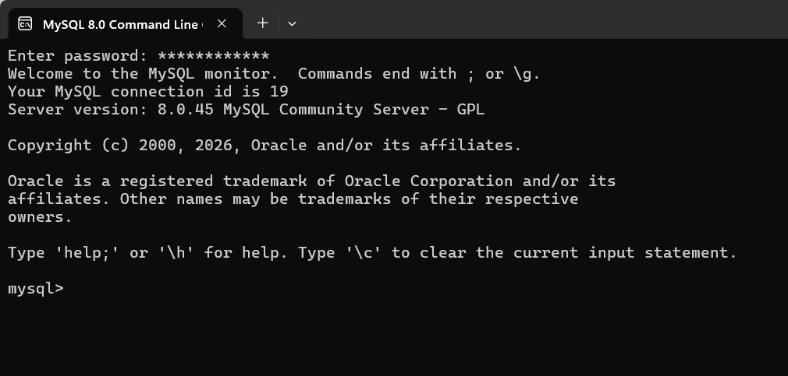
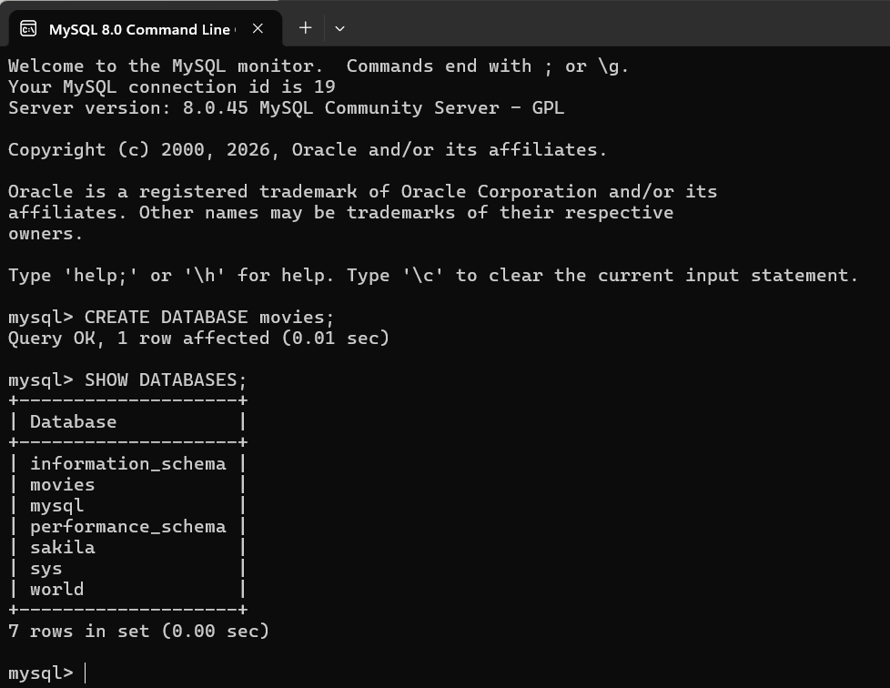
Function 1- UPPER()
The UPPER() function is used to convert text to uppercase. It’s useful when you want to standardize names, codes, or other text values so they are all in the same case for searching or comparison.
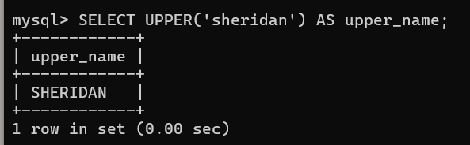
Function 2 – LENGTH ()
The LENGTH() function returns the number of characters in a string. It can be used to validate input (like checking if a password is long enough) or to analyze text data.
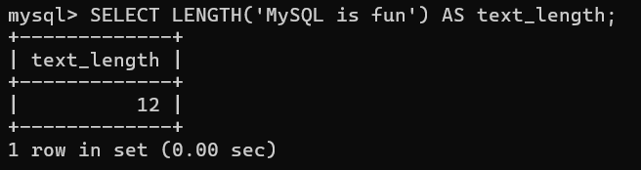
Function 3- LOWER ()
The LOWER() function converts any text string into lowercase letters. This is useful when you want to standardize text before comparing it. For example, usernames, emails, or product codes may be entered in different cases by different users, and converting everything to lowercase ensures consistent matching and searching.
